**PRACTICAL NO.4**

**Programs related to different Layouts**

**Coordinate, Linear, Relative, Table, Absolute, Frame, List View, Grid View.**

**Linear ,table-**

**Code:**

**activity_main.xml**

<?xml version="1.0" encoding="utf-8"?>  
<LinearLayout xmlns:android="http://schemas.android.com/apk/res/android"  
 xmlns:app="http://schemas.android.com/apk/res-auto"  
 xmlns:tools="http://schemas.android.com/tools"  
 android:layout_width="match_parent"  
 android:layout_height="match_parent"  
 android:orientation="vertical"  
 tools:context=".MainActivity"  
 >  
 <TableLayout  
 android:layout_width="match_parent"  
 android:layout_height="wrap_content"  
 android:layout_margin="10dp"  
 >

<TextView  
 android:id="@+id/res"  
 android:layout_width="match_parent"  
 android:layout_height="50dp"  
 android:text=""  
 android:textSize="40dp"  
 android:gravity="right"  
 />  
  
 <TableRow android:padding="2dp">  
 <Button  
 android:id="@+id/modulo"  
 android:text="%"/>  
 <Button  
 android:id="@+id/ce"  
 android:text="CE"  
 android:layout_marginLeft="10dp"/>  
 <Button  
 android:id="@+id/ac"  
 android:text="AC"  
 android:layout_marginLeft="10dp"/>  
 <Button  
 android:id="@+id/clear"  
 android:text="Clear"  
 android:layout_marginLeft="10dp"/>  
 </TableRow>  
  
 <TableRow android:padding="2dp">  
 <Button  
 android:id="@+id/one"  
 android:text="1"/>  
 <Button  
 android:id="@+id/two"  
 android:text="2"  
 android:layout_marginLeft="10dp"/>  
 <Button  
 android:id="@+id/three"  
 android:text="3"  
 android:layout_marginLeft="10dp"/>  
 <Button  
 android:id="@+id/add"  
 android:text="+"  
 android:layout_marginLeft="10dp"/>  
 </TableRow>  
  
 <TableRow>  
 <Button  
 android:id="@+id/four"  
 android:text="4"/>  
 <Button  
 android:id="@+id/five"  
 android:text="5"  
 android:layout_marginLeft="10dp"/>  
 <Button  
 android:id="@+id/six"  
 android:text="6"  
 android:layout_marginLeft="10dp"/>  
 <Button  
 android:id="@+id/sub"  
 android:text="-"  
 android:layout_marginLeft="10dp"/>  
 </TableRow>  
  
 <TableRow android:padding="2dp">  
 <Button  
 android:id="@+id/seven"  
 android:text="7"/>  
 <Button  
 android:id="@+id/eight"  
 android:text="8"  
 android:layout_marginLeft="10dp"/>  
 <Button  
 android:id="@+id/nine"  
 android:text="9"  
 android:layout_marginLeft="10dp"/>  
 <Button  
 android:id="@+id/mul"  
 android:text="X"  
 android:layout_marginLeft="10dp"/>  
 </TableRow>  
  
 <TableRow android:padding="2dp">  
 <Button  
 android:id="@+id/zero"  
 android:text="0"/>  
 <Button  
 android:id="@+id/point"  
 android:text="."  
 android:layout_marginLeft="10dp"/>  
 <Button  
 android:id="@+id/equal"  
 android:text="="  
 android:layout_marginLeft="10dp"/>  
 <Button  
 android:id="@+id/div"  
 android:text="/"  
 android:layout_marginLeft="10dp"/>  
 </TableRow>  
 </TableLayout>  
  
</LinearLayout>

**MainActivity.kt**

package com.example.demo  
  
import android.content.Intent  
import android.graphics.Color  
import androidx.appcompat.app.AppCompatActivity  
import android.os.Bundle  
import android.widget.Toast  
import kotlinx.android.synthetic.main.activity_calcu.*  
import kotlinx.android.synthetic.main.activity_main.*  
import kotlinx.android.synthetic.main.activity_main.add  
import kotlinx.android.synthetic.main.activity_main.clear  
import kotlinx.android.synthetic.main.activity_main.div  
import kotlinx.android.synthetic.main.activity_main.eight  
import kotlinx.android.synthetic.main.activity_main.equal  
import kotlinx.android.synthetic.main.activity_main.five  
import kotlinx.android.synthetic.main.activity_main.four  
import kotlinx.android.synthetic.main.activity_main.modulo  
import kotlinx.android.synthetic.main.activity_main.mul  
import kotlinx.android.synthetic.main.activity_main.nine  
import kotlinx.android.synthetic.main.activity_main.one  
import kotlinx.android.synthetic.main.activity_main.point  
import kotlinx.android.synthetic.main.activity_main.res  
import kotlinx.android.synthetic.main.activity_main.seven  
import kotlinx.android.synthetic.main.activity_main.six  
import kotlinx.android.synthetic.main.activity_main.sub  
import kotlinx.android.synthetic.main.activity_main.three  
import kotlinx.android.synthetic.main.activity_main.two  
import kotlinx.android.synthetic.main.activity_main.zero  
import kotlinx.android.synthetic.main.activity_second_page.*  
  
class MainActivity : AppCompatActivity() {  
 override fun onCreate(savedInstanceState: Bundle?) {  
 super.onCreate(savedInstanceState)  
 setContentView(R.layout.activity_main)  
 var lhs: Double = 0.0  
 var rhs: Double = 0.0  
 var op: Int = 0  
  
 one.setOnClickListener {  
 res.append(one.text.toString())  
 }  
 two.setOnClickListener {  
 res.append(two.text.toString())  
 }  
 three.setOnClickListener {  
 res.append(three.text.toString())  
 }  
 four.setOnClickListener {  
 res.append(four.text.toString())  
 }  
 five.setOnClickListener {  
 res.append(five.text.toString())  
 }  
 six.setOnClickListener {  
 res.append(six.text.toString())  
 }  
 seven.setOnClickListener {  
 res.append(seven.text.toString())  
 }  
 eight.setOnClickListener {  
 res.append(eight.text.toString())  
 }  
 nine.setOnClickListener {  
 nine.append(one.text.toString())  
 }  
 zero.setOnClickListener {  
 res.append(zero.text.toString())  
 }  
 point.setOnClickListener {  
 res.append(point.text.toString())  
 }  
 clear.setOnClickListener {  
 lhs = 0.0  
 rhs = 0.0  
 res.text = ""  
 }  
 add.setOnClickListener {  
 lhs = res.text.toString().toDouble()  
 res.text = ""  
 op = 1  
 }  
 sub.setOnClickListener {  
 lhs = res.text.toString().toDouble()  
 res.text = ""  
 op = 2  
 }  
 mul.setOnClickListener {  
 lhs = res.text.toString().toDouble()  
 res.text = ""  
 op = 3  
 }  
 modulo.setOnClickListener {  
 lhs = res.text.toString().toDouble()  
 res.text = ""  
 op = 5  
 }  
 div.setOnClickListener {  
 lhs = res.text.toString().toDouble()  
 res.text = ""  
 op = 4  
 }  
 equal.setOnClickListener {  
 var r: Double = 0.0  
 rhs = res.text.toString().toDouble()  
 if (op == 1) {  
 r = lhs + rhs  
 res.text = "$r"  
 } else if (op == 2) {  
 r = lhs - rhs  
 res.text = "$r"  
 } else if (op == 3) {  
 r = lhs * rhs  
 res.text = "$r"  
 } else if (op == 4) {  
 r = lhs / rhs  
 res.text = "$r"  
 } else if (op == 5) {  
 r = lhs % rhs  
 res.text = "$r"  
 }  
 }  
 }  
}

**Output:**

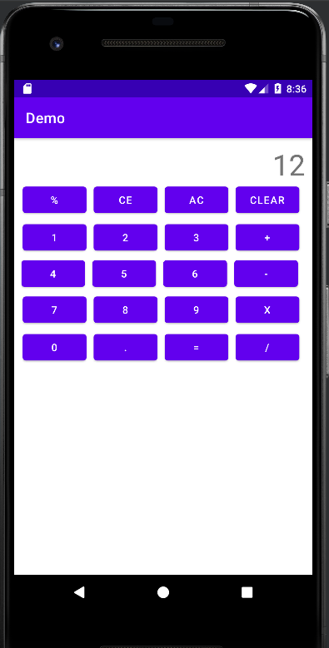 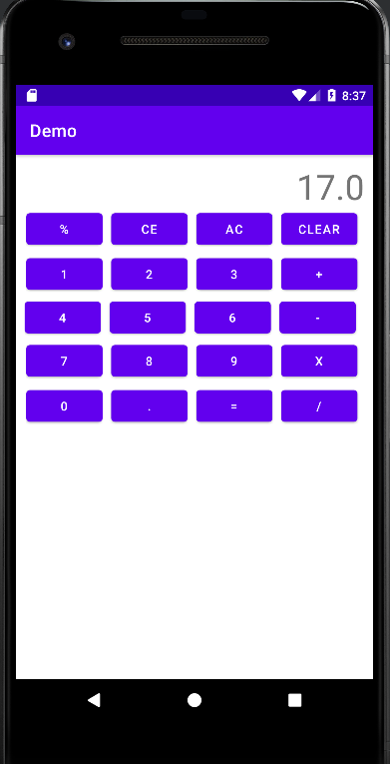

**List View,Relative,GridLayout:**

**Code:**

**activity_main.xml**

<?xml version="1.0" encoding="utf-8"?>  
<androidx.constraintlayout.widget.ConstraintLayout xmlns:android="http://schemas.android.com/apk/res/android"  
 xmlns:app="http://schemas.android.com/apk/res-auto"  
 xmlns:tools="http://schemas.android.com/tools"  
 android:layout_width="match_parent"  
 android:layout_height="match_parent"  
 tools:context=".MainActivity"  
 android:id="@+id/bg">  
  
 <ListView  
 android:id="@+id/mylist"  
 android:layout_width="409dp"  
 android:layout_height="500dp"  
 android:layout_marginStart="32dp"  
 android:layout_marginTop="150dp"  
 android:layout_marginEnd="32dp"  
 android:layout_marginBottom="32dp"  
 app:layout_constraintBottom_toBottomOf="parent"  
 app:layout_constraintEnd_toEndOf="parent"  
 app:layout_constraintStart_toStartOf="parent"  
 app:layout_constraintTop_toTopOf="parent"  
 app:layout_constraintVertical_bias="0.0" />  
  
 <Button  
 android:id="@+id/button"  
 android:layout_width="wrap_content"  
 android:layout_height="wrap_content"  
 android:text="Next"  
 app:layout_constraintBottom_toBottomOf="parent"  
 app:layout_constraintEnd_toEndOf="parent"  
 app:layout_constraintStart_toStartOf="parent" />  
</androidx.constraintlayout.widget.ConstraintLayout>

**MainActivity.kt**

package com.example.myapp  
import android.content.Intent  
import android.graphics.Color  
import androidx.appcompat.app.AppCompatActivity  
import android.os.Bundle  
import android.widget.ArrayAdapter  
import android.widget.Toast  
import kotlinx.android.synthetic.main.activity_main.*  
  
class MainActivity : AppCompatActivity() {  
 override fun onCreate(savedInstanceState: Bundle?) {  
 super.onCreate(savedInstanceState)  
 setContentView(R.layout.activity_main)  
  
 var colors= arrayOf("Red","Blue","Green","Yellow")  
 var myad=ArrayAdapter(this,android.R.layout.simple_list_item_1,colors)  
 mylist.adapter=myad  
 mylist.setOnItemClickListener { adapterView, view, i, l ->  
 var data=mylist.getItemAtPosition(i).toString()  
 when{  
 data=="Red" ->bg.setBackgroundColor(Color.RED)  
 data=="Blue" ->bg.setBackgroundColor(Color.BLUE)  
 data=="Green" ->bg.setBackgroundColor(Color.GREEN)  
 data=="Yellow" ->bg.setBackgroundColor(Color.YELLOW)  
 }  
 }  
 button.setOnClickListener {  
 var nextPage=Intent(this,GridDemo::class.java)  
 startActivity(nextPage)  
 }  
 }  
}

**activty_grid_demo.xml**

<?xml version="1.0" encoding="utf-8"?>  
<RelativeLayout xmlns:android="http://schemas.android.com/apk/res/android"  
 xmlns:app="http://schemas.android.com/apk/res-auto"  
 xmlns:tools="http://schemas.android.com/tools"  
 android:layout_width="match_parent"  
 android:layout_height="match_parent"  
 tools:context=".GridDemo">  
 <GridLayout  
 android:layout_width="500dp"  
 android:layout_height="500dp"  
 android:columnCount="3">  
 <Button android:text="Hello"></Button>  
 <Button android:text="Hello"></Button>  
 <Button android:text="Hello"></Button>  
 <Button android:text="Hello"></Button>  
 <Button android:text="Hello"></Button>  
 <Button android:text="Hello"></Button>  
 </GridLayout>  
</RelativeLayout>

**GridDemo.kt**

package com.example.myapp  
import androidx.appcompat.app.AppCompatActivity  
import android.os.Bundle  
class GridDemo : AppCompatActivity() {  
 override fun onCreate(savedInstanceState: Bundle?) {  
 super.onCreate(savedInstanceState)  
 setContentView(R.layout.activity_grid_demo)  
 }  
}

**Output:**

**activity_main.xml**

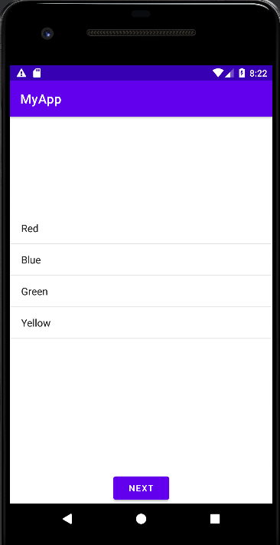 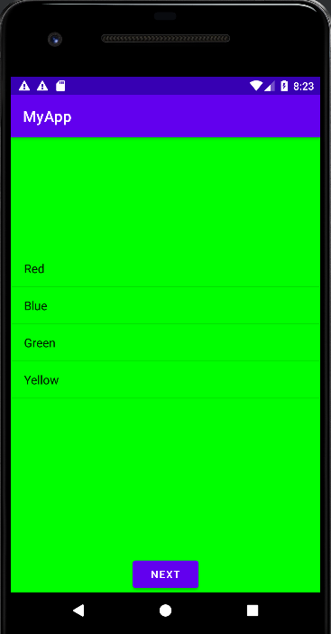

**activty_grid_demo.xml**

